Insert your company logo here

Support Workers Doing Positive Behavioural Support Well

Competence Checklist

Name: ........................................................

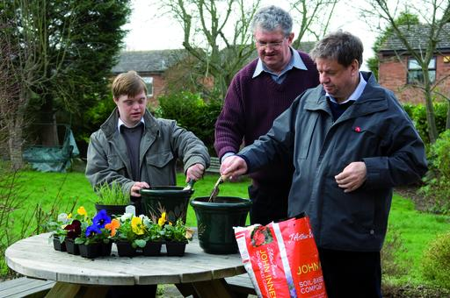



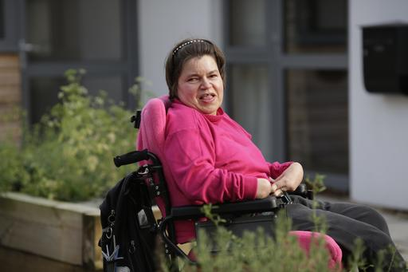
Competence Area 1. Creating high quality care and support environments
Things you need to know

We can reduce the likelihood of challenging behaviour occurring by providing supportive physical environments and opportunities for interaction and activity with the right kind of support. Things you need to know in relation to this include:

- Respecting each person as an individual with the same human rights as everyone else
- Appreciating and supporting a person’s social, physical and mental health needs
- Supporting communication and choices
- Supporting participation in activities people enjoy
- Matching support to an individual’s needs as well as their likes/dislikes
- Creating safe, consistent and predictable environments
- Building upon and teaching new skills
- Supporting relationships with the person’s family, friends and their wider community
- Adopting the least restrictive support (and the legislation supporting this)

PBS knowledge competencies completed on: ................................................. Sign off & date: .....................................................

Skill Area | Evidence of things you need to do | Sign off & date | Details of things you require to achieve this
1. Understand person-centred approaches, inclusion and the need for people’s human rights to be respected. | - Show dignity, respect, warmth, empathy, and compassion in all your interactions  - Treat every individual as a person and support individual needs  - Support people to take part in everyday activities and be part of their community  - Provide opportunities for learning and development  - Support behaviour and daily interactions that make the person look and feel good.  - Minimise any restriction of activities  - Apply key points from legislation in all care and support
Skill Area | Evidence of things you need to do | Sign off & date | Details of things you require to achieve this
2. Understand the importance of getting to know a person and finding out about their family, their history, likes/dislikes, skills and how someone communicates their needs. | - Develop a positive relationship with the person  - Be able to give examples of how the person shows enjoyment and displeasure in activities  - Support the person to have the things that are important to them, as well as the things necessary to create a good quality of life.  - Support the person in a range of activities and situations.  - Be able to reflect on your relationship with the person
3. Appreciate how to match support to each individual and set goals that are important to the person. | - Collect information about a person’s strengths, needs, likes/dislikes, hopes, dreams and desires (from the person themselves, family and others)  - Design a person’s timetable to provide opportunities to work towards goals  - Help measure progress on the person’s goals  - Ensure there is a balance of goals which reflect an overall quality of life
4. Understand your role and that of others and the need for effective team. | - Offer support that enables a person rather than doing too much for them  - Act as a key worker for at least one person  - Actively participate in teamwork including meetings, supervision, supporting colleagues.  - Seek support from others when required  - Attend to your own physical and emotional  well-being and seek support to manage your work  - Show ability to reflect on your own actions and feelings and awareness of their impact on others.  - Participate in training programmes identified for all staff
Skill Area | Evidence of things you need to do | Sign off & date | Details of things you require to achieve this
5. Support communication and choice | - Show effective communication using a range of methods, (e.g., nonverbal, verbal, gestures, pictures)  - Get to know how a person communicates best and support the use and development of this  - Adapt your communication to the needs of the person  - Communicate with colleagues, families, professionals in an appropriate way  - Provide opportunities for a person to make informed choices (big and small) and help teach the person how to do this.  - Respect a person’s choices even if they are not consistent with your own.
6. Support physical and mental health | - Support individuals to maintain physical/mental health and wellbeing (e.g. cleaning teeth, checking testicles, healthy eating, exercise, mindfulness etc.)  - Use individual health care plans (including competent administration of medication) and record/report appropriately  - Support the use of health care, e.g. visiting GP  - Identify and interpret a person’s physical and emotional state from non-verbal behaviours (i.e. facial expression, body movements, other behaviour)  - Seek support/advice from senior manager or clinician when needed  - Be able to talk about your thoughts and feelings in relation to the management of a person’s health
7. Support relationships with family, friends and wider community | - Actively work with professionals, family and friends.  - Actively develop/support friendships and relationships with others by supporting the person to make contact, visit people, arrange social events etc.  - Use formal and informal ways of sharing information (as appropriate)  - Seek advice from others (family, friends, professionals) regarding best interest decisions
Skill Area | Evidence of things you need to do | Sign off & date | Details of things you require to achieve this
8. Support safe, consistent and predictable environments | - Use strategies to help the person predict, understand and control their environment (e.g. visual timetable, social stories)  - Develop personal activity plans with routine activities and choices  - Identify and avoid if possible, aspects of the environment that may be a risk factor for challenging behaviour  - Use strategies designed to help people cope with difficult environments
9. Support participation in meaningful activity | - Find out about different activities a person likes and create opportunities for these every day  - Make sure there is at least one activity available at all times with necessary support available  - Help the person do things they do not like, but that are essential. Offer extra motivation and reward for these things  - Introduce new activities so that a person has more activities to choose from  - Support the person to develop skills in order to do things as independently as possible  - Break down complex activities into smaller steps and adapt support so the person can do as much as possible  - Keep track of what people do to make sure there is a good balance of activities which offer variety, occur often enough and are of good quality

Competence Area 2: Assessment of behaviour and skills

Things you need to know

We know that the best support is based on a thorough understanding of a person’s needs and abilities.
Things you need to know in relation to this include:
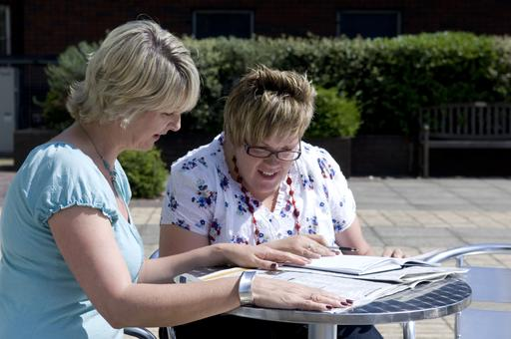
- Importance of working in partnership with others
- Need to assess the match between the person and their environment
- Knowing the health of the person
- Understanding the principles of behaviour and that all behaviour
     occurs for a reason
- Using clear information (data) to support all decisions about a person’s support
- Need to assess the function (reason) of a person’s behaviour
- Need to assess a person’s skills and understand their abilities (including the
impact of their learning disability)
- Importance of assessing a person’s likes/dislikes and understanding
what motivates someone

PBS knowledge competencies completed on: ................................................. Sign off & date: .....................................................

Skills Area | Evidence of things you need to do | Sign off & date | Details of things you require to achieve this
1. Work in partnership with others to complete assessments and develop appropriate support | - Contribute information to the assessment process  - Support the person to contribute to their own assessment  - Recognise and support others involved in assessment/support and understand the reasons for their contribution
2. Assess the match between the person and their environment and ability of a service to deliver support | - Provide information about practical aspects of completing assessment and using a proposed behaviour support plan (BSP)/PBS plan.  - Identify and help resolve any barriers during assessment or use BSP/PBS plan (e.g. staffing, shift patterns, equipment)
Skill Area | Evidence of things you need to do | Sign off & date | Details of things you require to achieve this
3. Know the health of the person | - Support the person through any medical assessment needed  - Participate in assessing mental capacity of the person in all aspects of everyday care  - Monitor health of the person and report any changes that may require assessment  - Recognise and report any signs of distress in the person that may indicate a health problem
4. Understand the principles of behaviour and that all behaviour occurs for a reason | - Identify and clearly describe behaviour and environmental factors in observable and measureable terms (clear descriptions and not judgements)  - Identify and report other things that might affect the person (e.g. illness, relocation, medication)  - Recognise the effect of own behaviour on the person and try to adapt this
5. Use clear information (data) for all decisions | - Record information according to the agreed procedures, e.g. ABC forms, behaviour recording forms  - Record information required for assessments objectively, e.g. level of independence in tasks  - Record a range of information to develop an understanding of the person’s skills and needs
6. Assess a person’s likes/dislikes, abilities and understand what motivates them | - Identify what is important for the person, their likes and dislikes and contribute this information to the BSP  - Distinguish between what is important to and important for the person  - Identify a person’s abilities and use these to build new skills

Competence Area 3: Developing, using and checking the effectiveness of a
Behaviour Support Plan (BSP)
Things you need to know

We know that support is most likely to be effective when everyone supporting a person follows the same strategies. One way of achieving this is by using a behaviour support plan (BSP) or PBS Plan. Things you need to know in relation to this include:
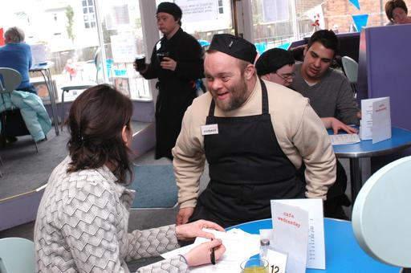
- Purpose of a BSP/PBS plan; roles, responsibilities and timescales
- Why we use data to understand a person’s skills and needs
- Understanding the reasons for a person’s challenging behaviour, the
situations it is likely to occur and the range of factors that maintain it
- Antecedent strategies (proactive and preventative strategies)
- Teaching new skills and alternatives to behaviour which challenges
- Reactive strategies including the use of the least restrictive crisis management
strategies
- Importance of monitoring the delivery and effectiveness of the BSP/PBS plan

PBS knowledge competencies completed on: ................................................. Sign off & date: .....................................................

Skill Area | Evidence of things you need to do | Sign off & date | Details of things you require to achieve this
1. Understand and use a BSP/PBS plan | - Be able to understand a person’s BSP/PBS plan  - Demonstrate the ability to carry out strategies correctly  - Participate in training, supervision and feedback on the correct use of BSP/PBS plan
2. Understand the reasons for a person’s challenging behaviour | - Identify things in the environment which make challenging behaviour more likely for the person
Skill Area | Evidence of the things you need to do | Sign off & date | Details of things you require to achieve this
3. Develop proactive strategies and teach new skills/ alternative behaviours based on an understanding of the person’s needs | - Help identify and use strategies that support the person to have a good quality of life and reduce the likelihood of behaviour which challenges from occurring. These may include:  - a physical environment that matches a person’s needs  - use of preferred communication  - increase engagement in activity for a person  - increase choice and independence for a person  - support to ensure physical and mental well being  - Teach and support the development of new skills/communication either as an alternative to challenging behaviour or as part of developing independence.  - Use strategies derived from behaviour analysis to teach complex new skills including: reinforcement, schedules of reinforcement, completing a task analysis, chaining, prompting and prompt fading, modelling and imitation and shaping behaviour
4. Develop and use preventative strategies when early signs of challenging behaviour occur | - Identify early warning signs (distress) that challenging behaviour may occur.  - Identify where on the cycle of arousal a person is at and respond accordingly  - Use a range of de-escalation techniques  - Change strategies (e.g. lower demands, modify physical environment; clarify routines at different stages of cycle)  - Prompt the person to use an alternative behaviour/new skill, e.g. Using a card to indicate a break is required.
5. Use the least restrictive crisis management strategy  (Reactive strategies) | - Check you understand crisis management strategies in the BSP/PBS plan  - Remain calm and use the crisis plan quickly, ensuring safety of everyone.  - Use ethical reactive strategies  - Record and report accurately (e.g. strategies used, details of the incident, injuries sustained).  - Use knowledge from training when unplanned strategies are needed  - Seek help when necessary and recognise your own signs of stress and anxiety  - Reflect on experience of delivering reactive strategies
Skill Area | Evidence of the things you need to do | Sign off & date | Details of things you require to achieve this
6. Help develop a BSP/PBS plan which identifies clear responsibilities and timeframes | - Check understanding of your role and responsibilities within the BSP/PBS plan  - Support all colleagues/family in understanding the plan especially new staff  - Highlight any misunderstandings or difficulties in using the BSP/PBS plan to supervisor
7. Monitor and evaluate the use BSP/PBS plan and make changes where necessary | - Describe the goals of the BSP/PBS plan and collect data (information) related to them as requested  - Identify the possible outcomes of failing to follow the BSP/PBS plan, e.g. increase in challenging behaviour, things that prevent the person learning skills, not helping the person to have a better quality of life etc.  - Reflect on your own practice, and that of other team members and try to ensure that everyone follows the plan  - Monitor progress and report changes in challenging behaviour, development of skills and participation in activities and other quality of life indicators  - Complete records and other documents that help monitor the use of the BSP/PBS plan  - Identify and report obstacles to using the BSP/PBS plan (e.g. a new team member who does not understand a strategy, part of BSP out of date etc.)  - Provide feedback on what worked well and what could have worked better  - Regularly attend and participate in supervision and review meetings  - Communicate any changes made to a BSP/PBS plan and ensure new strategies are used consistently.

